Name: Astha Arpit Bhatt

Enroll: 196140316006

**Practical 10**

Aim: Develop a program that draws two sets of ever-decreasing rectangles one in outline form and one filled alternately in black and white.

import java.awt.*;

public class pra10 extends Canvas

{

Frame f;

public pra10()

{

f = new Frame("Practical - 10");

f.setSize(500,300);

f.setVisible(true);

f.setLayout(new FlowLayout());

setSize(400,200);

setVisible(true);

f.add(this);

}

public void paint(Graphics g)

{

g.setColor(Color.RED);

g.fillRect(0,0,400,200);

int x=0;

int y=0;

int width=400;

int height=200;

int i=0;

while(i<19)

{

width=width-10;

height=height-10;

x=(400-width)/2;

y=(200-height)/2;

if(i%2==1)

g.setColor(Color.WHITE);

else

g.setColor(Color.BLACK);

g.fillRect(x,y,width,height);

i++;

try

{

Thread.sleep(1000);

}

catch(InterruptedException e)

{}

}

}

public static void main(String a[])

{

pra10 fd = new pra10();

}

}

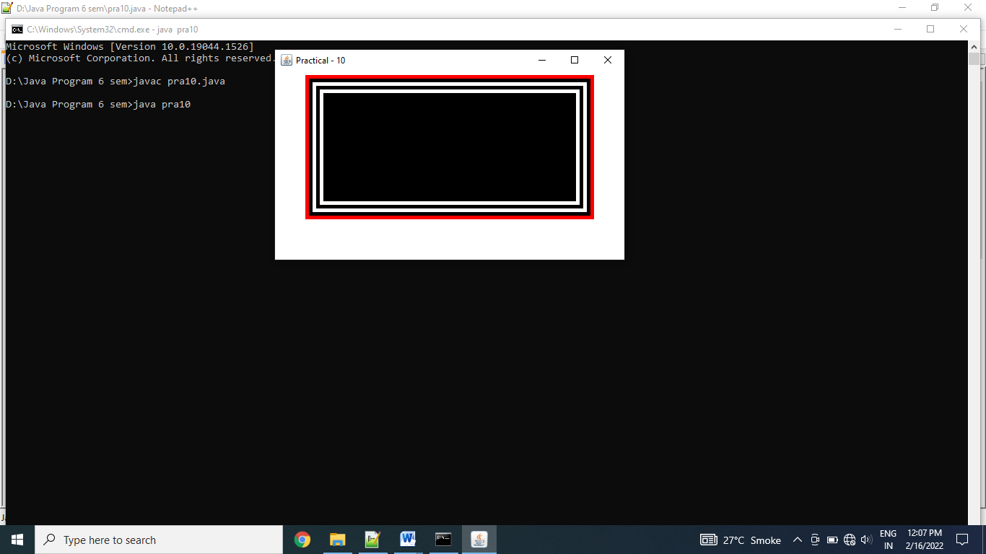

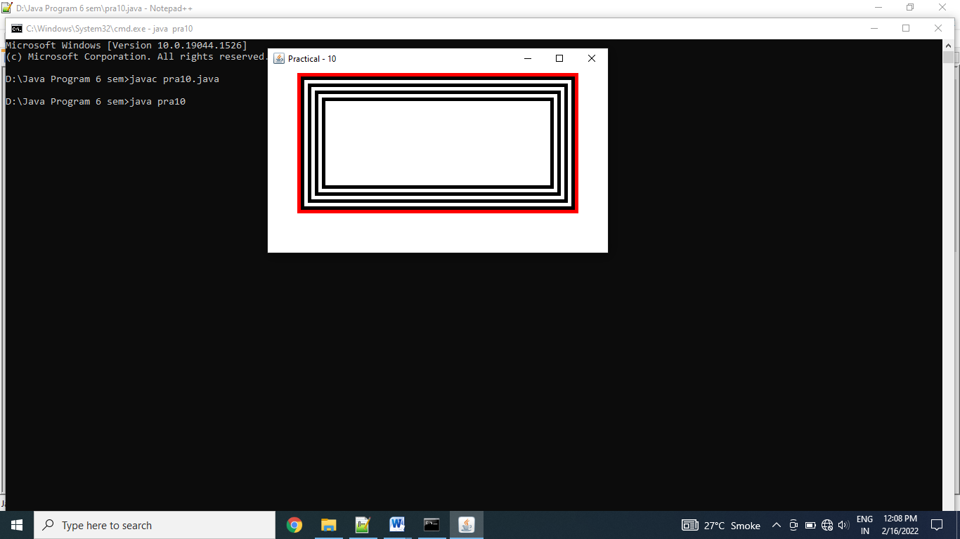

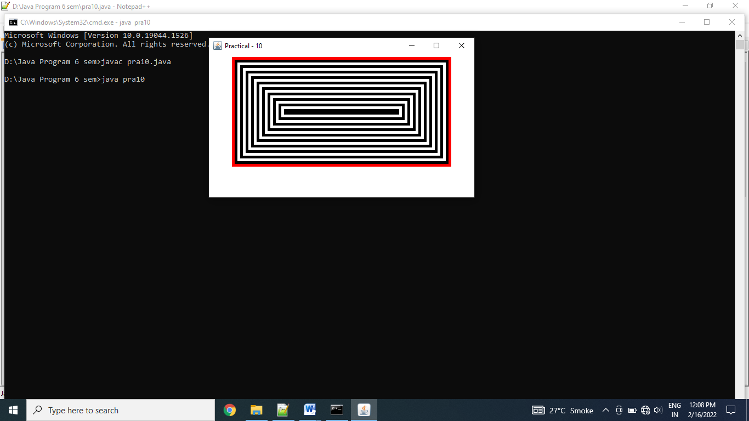

Exercise:  
Write an AWT GUI application. Each time the "Count" button is clicked, the counter value shall increase by 1.

import java.awt.*;

import java.awt.event.*;

public class AWTCounter extends Frame implements ActionListener

{

Label l;

TextField tf;

Button b;

int count = 0;

public AWTCounter()

{

setLayout(new FlowLayout());

l = new Label("Counter");

add(l);

tf = new TextField(count + "",10);

tf.setEditable(false);

add(tf);

b = new Button("Count");

add(b);

b.addActionListener(this);

setSize(300,300);

setVisible(true);

setTitle("AWT Counter");

}

public void actionPerformed(ActionEvent e)

{

++count;

tf.setText(count+ "");

}

public static void main(String args[])

{

AWTCounter ob = new AWTCounter();

}

}

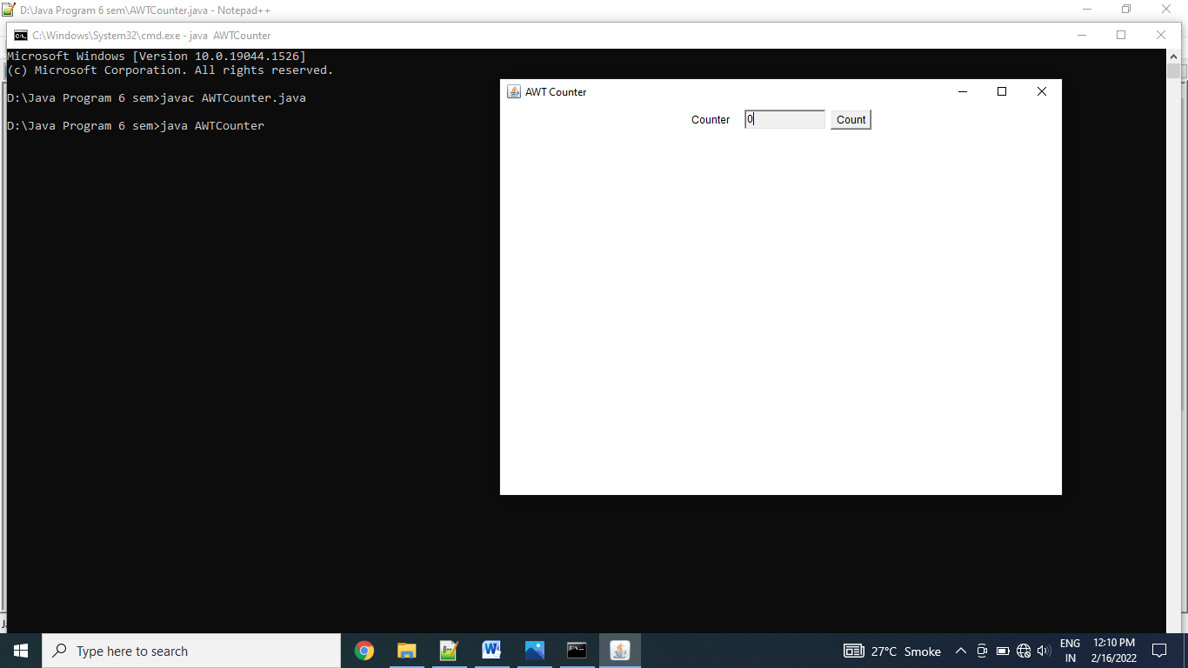

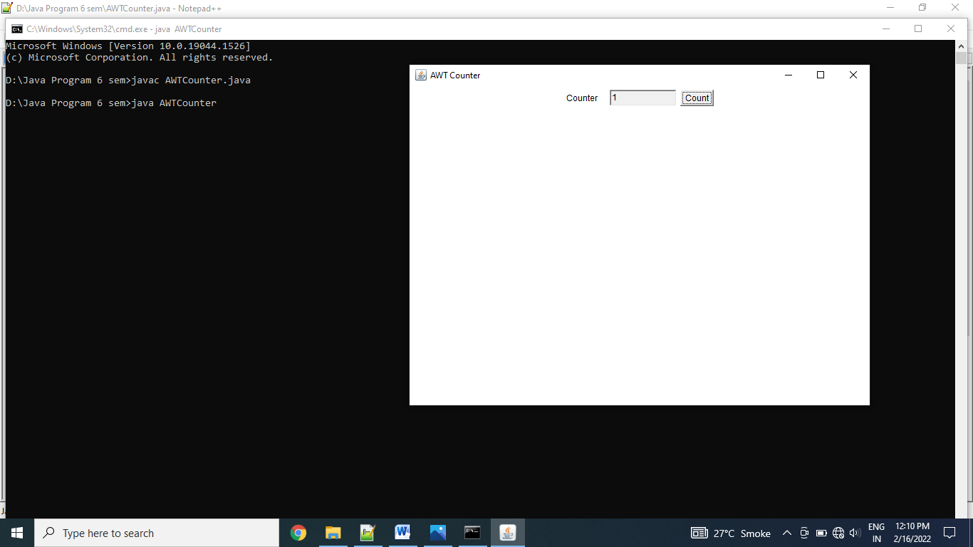

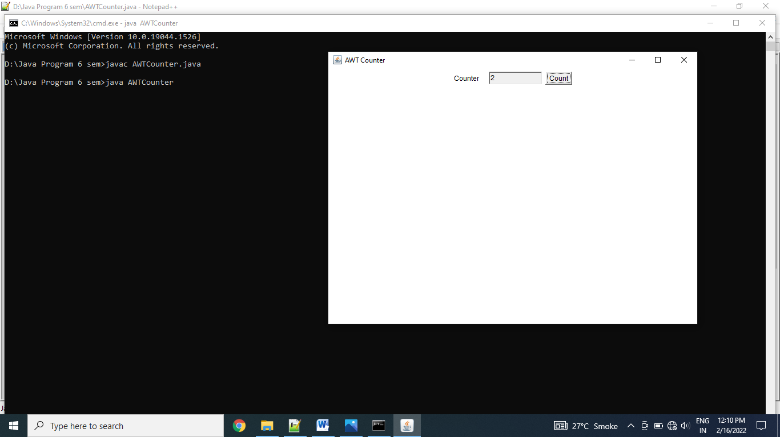

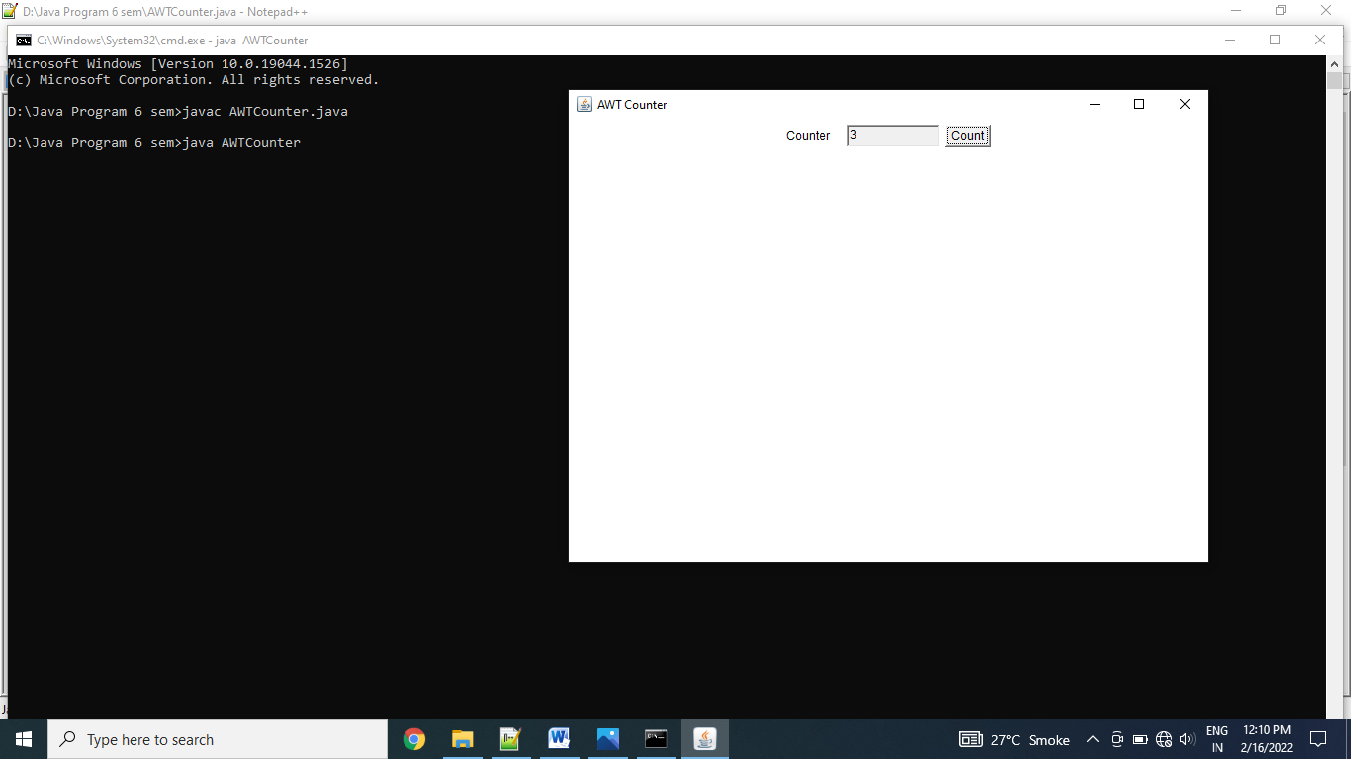

Thanks mam!!